
Official league roster – SOCCER 2022
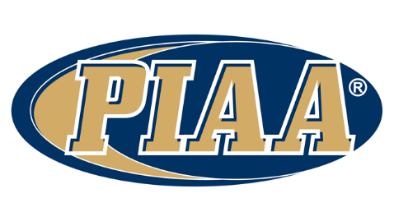
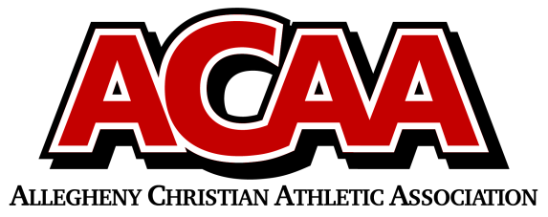

School Name: Meadowbrook Christian
Team Colors: Forest Green / White
Overall Wins ___ Losses ____ Ties ___
ACAA Wins ___ Losses ____ Ties ___ OPPONENT: __________________________
Date: _________
 | Name | Year | Position | Height | Homeschool
3/55 | Michael Eager | 12th | GK
8 | Brandon Garcia | 12th | Mid
30 | Keegan Gill | 12th
10 | Gavin Millett | 12th | Mid
12 | Chris Reed | 12th | Mid
26 | Jacob Reed | 12th | Defense
23 | Josh Bakowicz | 11th
29 | Nick Bennage | 11th | Defense
30 | Jayar Rhoades | 11th
13/0 | Josiah Baker | 10th | GK/Defense
5 | Levi Erb | 10th | Defense
22 | Garrett Knopp | 10th | 22
14 | Luke Osman | 10th | Striker
6 | Joah Robel | 10th
2 | Austin Steck | 10th | Mid
7 | Jaden Garcia | 9th

VARSITY BOYS
Head Coach: MICHAEL MILLETT
Asst. coach: Collin Erb
Asst. coach: Jeff Williams
Asst. coach:
Athletic Director: Samantha DeLong

Official ACAA League Team Roster. to be submitted to the scorer’s table before each game.

